The Assignment was to create a movie database with a login and the ability to search by user, rating and movie.

I created a Main, BestMovie4uAPI, AdminMenu and DefaultMenu combined with cliché to allow the user to log in.

To log in as a User, with User privileges the command is li 0 user

To log in as Admin, with more options the command is li -99 secret

The functionality currently is:

get-user: retrieves the user by number. get-user 1 retrieves the first user record.

get-users: retrieves all the users.

get-movies: retrieves all the movies.

get-rating: retrieves a single rating by id.

get-movie: retrieves the movie by title.

delete-user: deletes the user by id.

In order to Iterating through a hashmap, I used keyset().

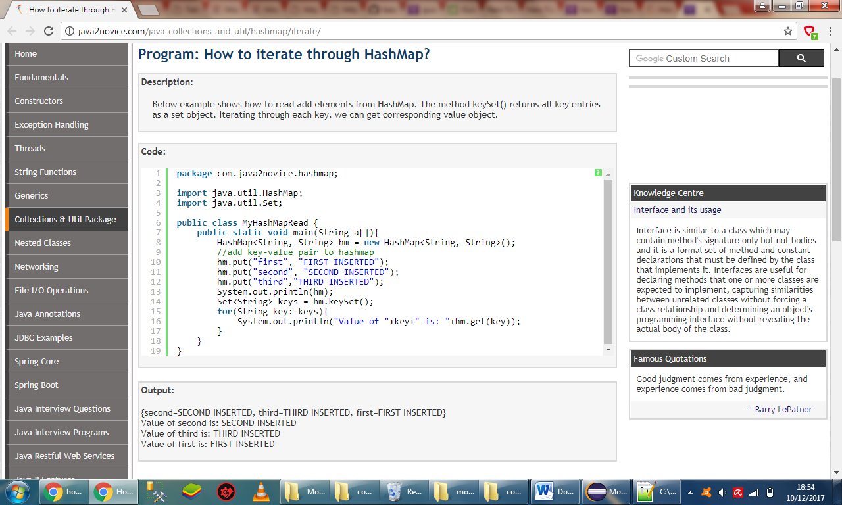

Then to find wether a specified value exists or not I used .containsValue()

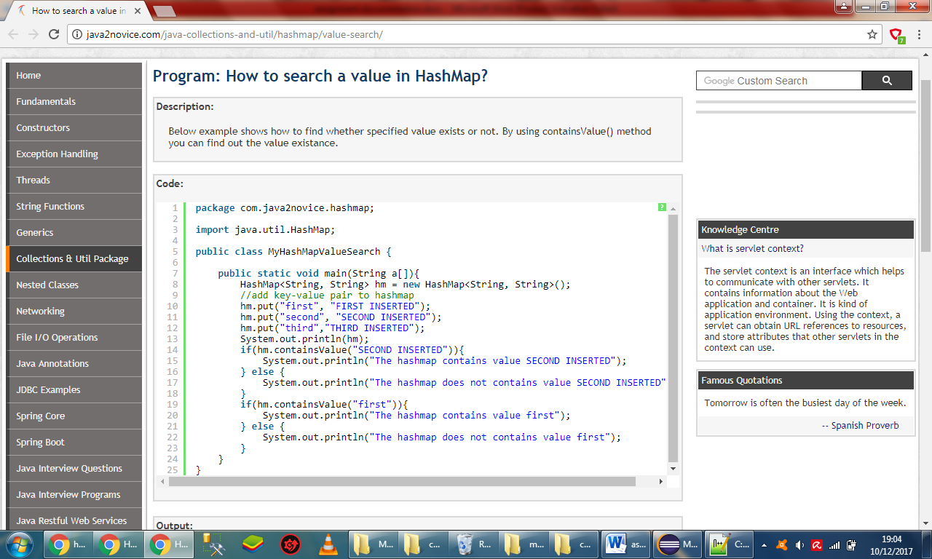

I then returned the correct movie object. If the search word was not in the title I returned null.